RETAIL SALES PERFORMANCE

Project Objective :
To analyse and visualize the sales performance of a retail company across products, regions, and time, enabling management to make accurate and data-driven business decisions.

Data Source:
The dataset consists of detailed retail transactional information, including Order ID and Order Date under order details, Customer Name and Segment under customer details, and Region as part of the geographical information. It also includes comprehensive product information such as Product Category, Sub-Category, and Product Name, along with key financial metrics like Sales, Quantity, Profit, and Discount. The data was thoroughly cleaned, structured, and then imported into Tableau for further analysis.

Proposed Visualizations:

Sales Overview Dashboard:

The Sales Overview Dashboard provides a high-level summary of the company’s performance across sales, profit, discount, and regional distribution. It is designed to help management quickly understand how the business is performing and identify monthly trends or regional variations.
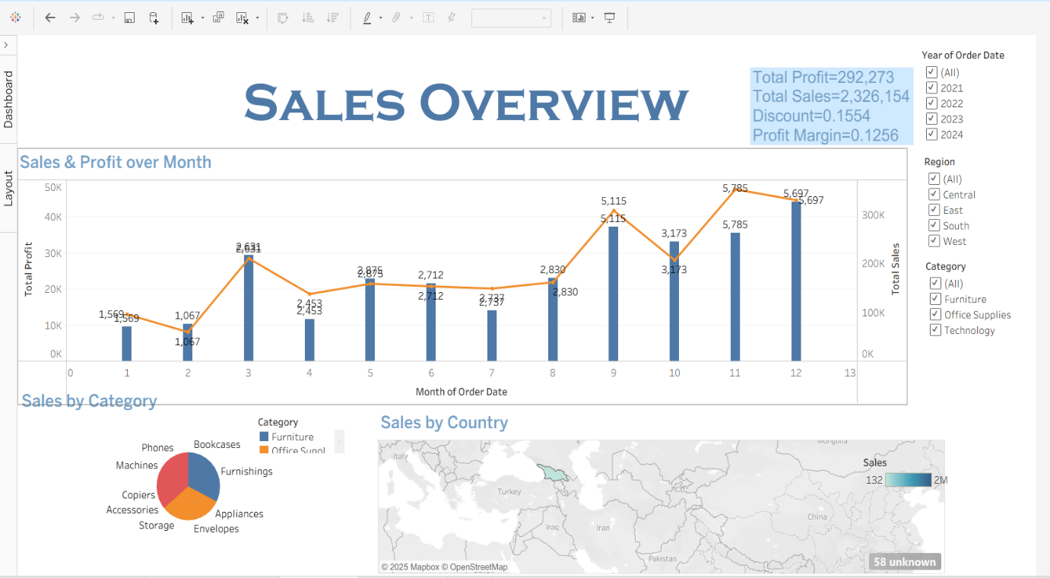
Sales Dashboard

KPI cards:
The dashboard starts with key performance indicators that give a quick overview of business performance. It shows the total sales earned, total profit made, and the average discount given on orders. It also displays the profit margin, which tells how efficiently the company turns sales into profit. These KPIs provide a clear and instant understanding of the company’s overall health.
- Sales & Profit Trend Line Chart:
The top chart shows monthly sales and profit together. The bars show how much profit was made each month, and the line shows the total sales for that month. This helps you easily compare both values and see how they change over time. If sales and profit rise together, business is doing well. If sales go up but profit drops, it may mean higher discounts or costs. Overall, this graph helps you understand which months perform better and which ones need attention.
- Sales by Category:
The pie chart shows how much each product category contributes to total sales, making it easy to see which category earns the most revenue
- Sales by Country:
The Country map highlights sales performance across different areas, with darker colors showing stronger sales. This helps identify both high-performing and weak country
- Filters used:
The dashboard includes interactive filters for:Year of Order Date,Region,Category

- Product Performance Analysis:
This dashboard helps understand how different products and categories contribute to overall sales and profit.

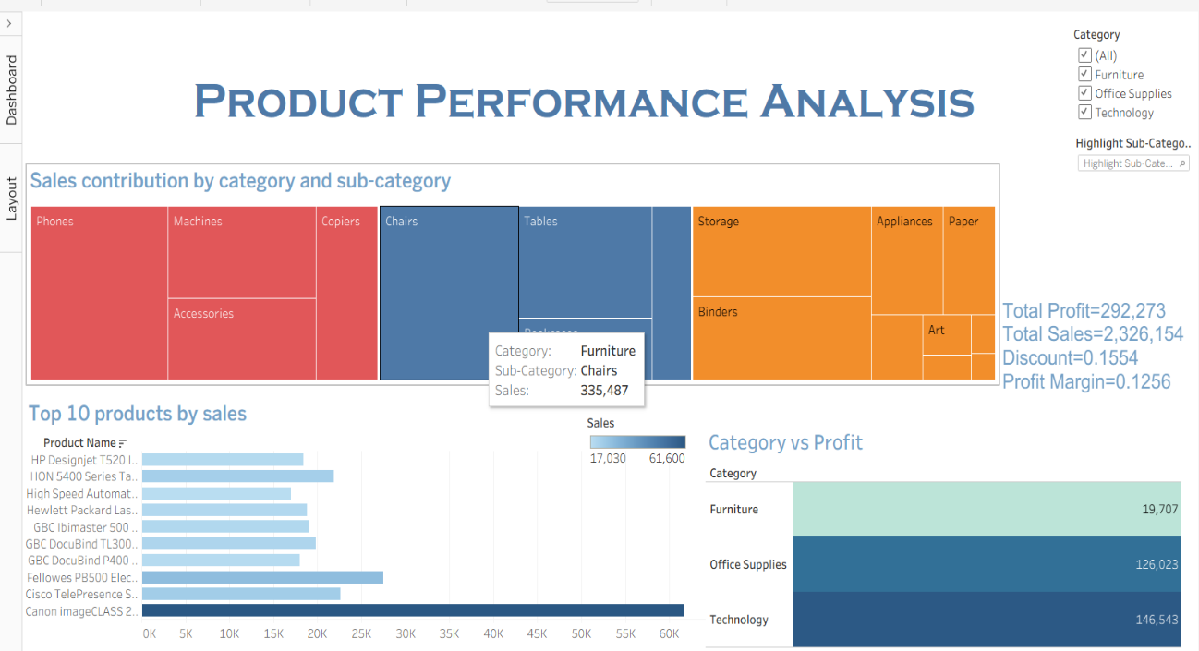
Product performance dashboard

- Sales Contribution by Category & Sub-Category:
The treemap shows how much each product category (Furniture, Office Supplies,Technology) and their sub-categories contribute to total sales.
• Larger boxes represent higher sales.
• Different colors represent different categories.
This helps quickly identify top-earning sub-categories like Chairs, Phones, Machines, etc.
- Top 10 Products by Sales:
The horizontal bar chart displays the top 10 best-selling products.we can instantly see which individual products generate the most revenue.
- Category vs Profit:
The chart compares the total profit earned by each category.It clearly shows which category is the most profitable and which ones need attention.
- Drill-Through Functionality:
created two extra sheets for drill-through:
• Product Details Sheet – Shows detailed product information when a user clicks a product.
• Sub-Category Sales Sheet – Shows sales for the selected sub-category.

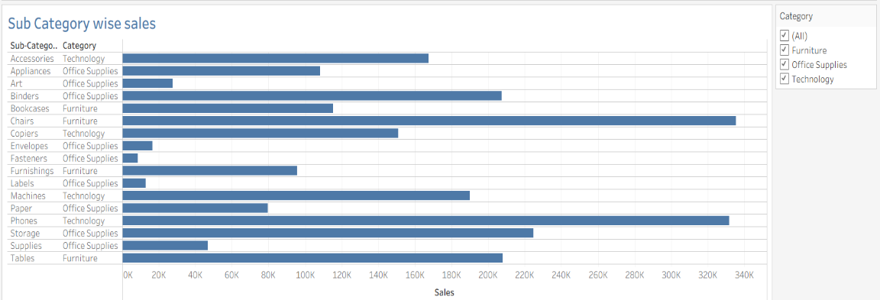
Sub category wise sales
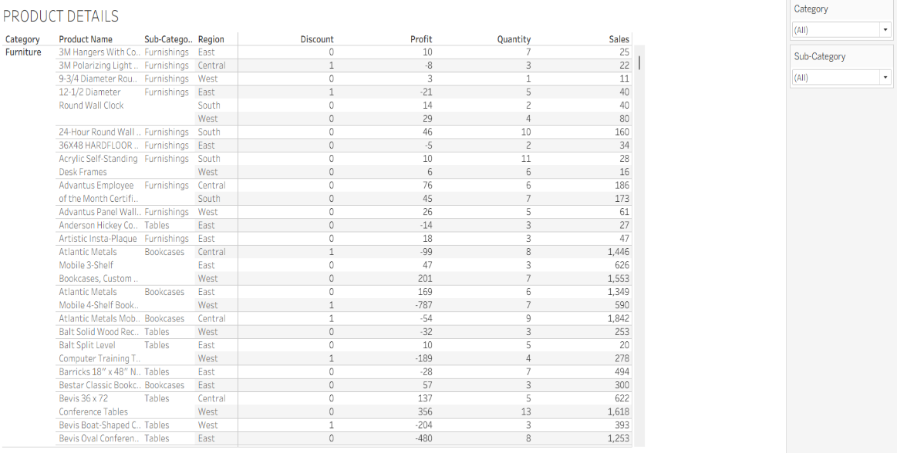
Product Details Sheet

- Customer Analysis
This dashboard shows top customers and segment-wise sales contribution, helping identify the most profitable customer segments.
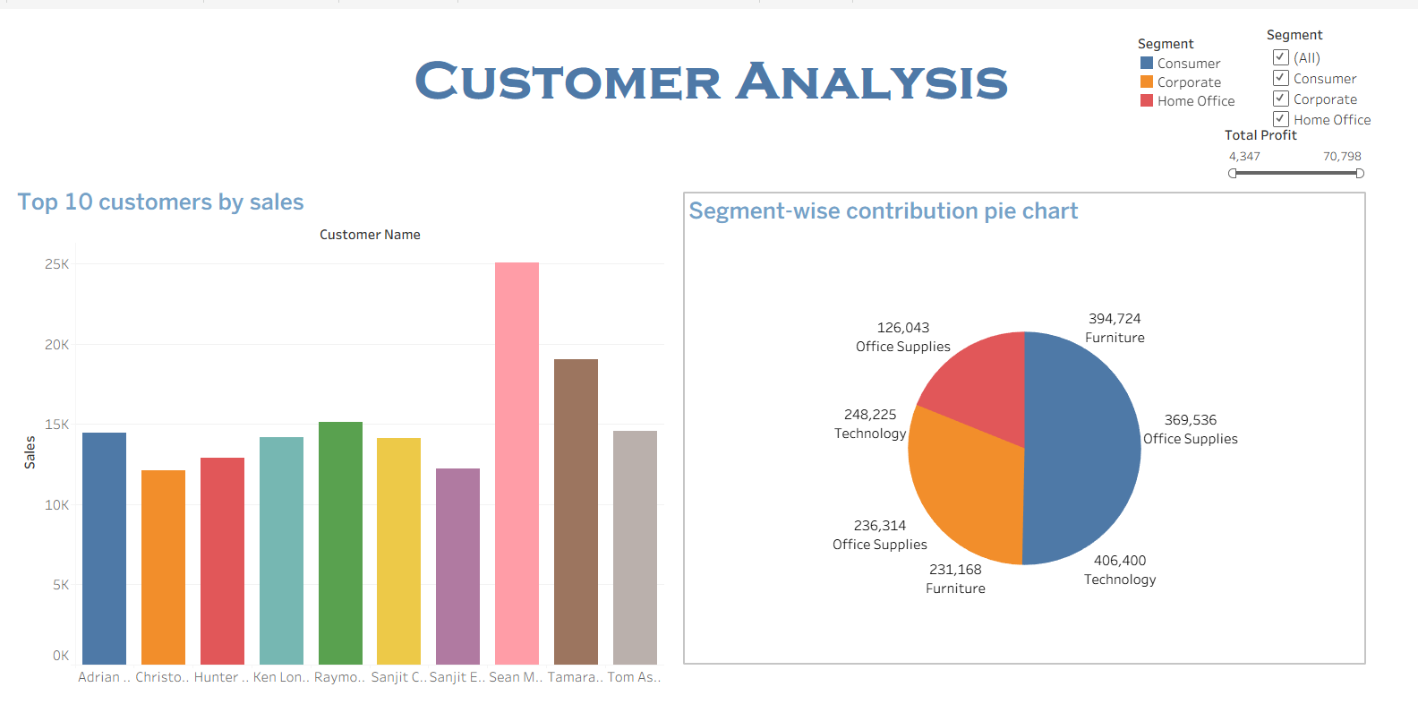
Customer Dashboard

- Top 10 Customers by Sales:
This bar chart shows the 10 customers who spent the most money. It helps to see which customers give the highest sales to the company. When you move the mouse on a bar, you can see more details like how many orders they made, how much profit we got, and what discounts they received.
- Segment-Wise Contribution:
This pie chart shows how much each customer segment contributed to total sales. It helps to quickly compare which segment brings the most sales.This is useful for deciding where to focus more business and marketing.
- Tooltip:
When you hover over any customer bar, it shows:Name of the customer,Total sales,Number of orders,Total profit,Average discount.This helps easily understand which customers are not only spending more but also giving more profit.

- Discount vs Profit Analysis:
- The scatter chart shows the relationship between discount and profit for each product. Each point is colored by product category, helping compare Office Supplies, Furniture, and Technology. If we click on any data point, we can drill down to see detailed information about that specific product.
- The trend line chart on the right shows how discounts and profits change over the years, helping understand whether increasing discounts lead to higher or lower profits over time.
- Monthly Trend with Parameter Control:
The chart shows how the selected measure (Sales / Profit / Quantity / etc.) changes month-by-month. The parameter control lets the user switch between different metrics, helping compare their trends over time on a single chart.

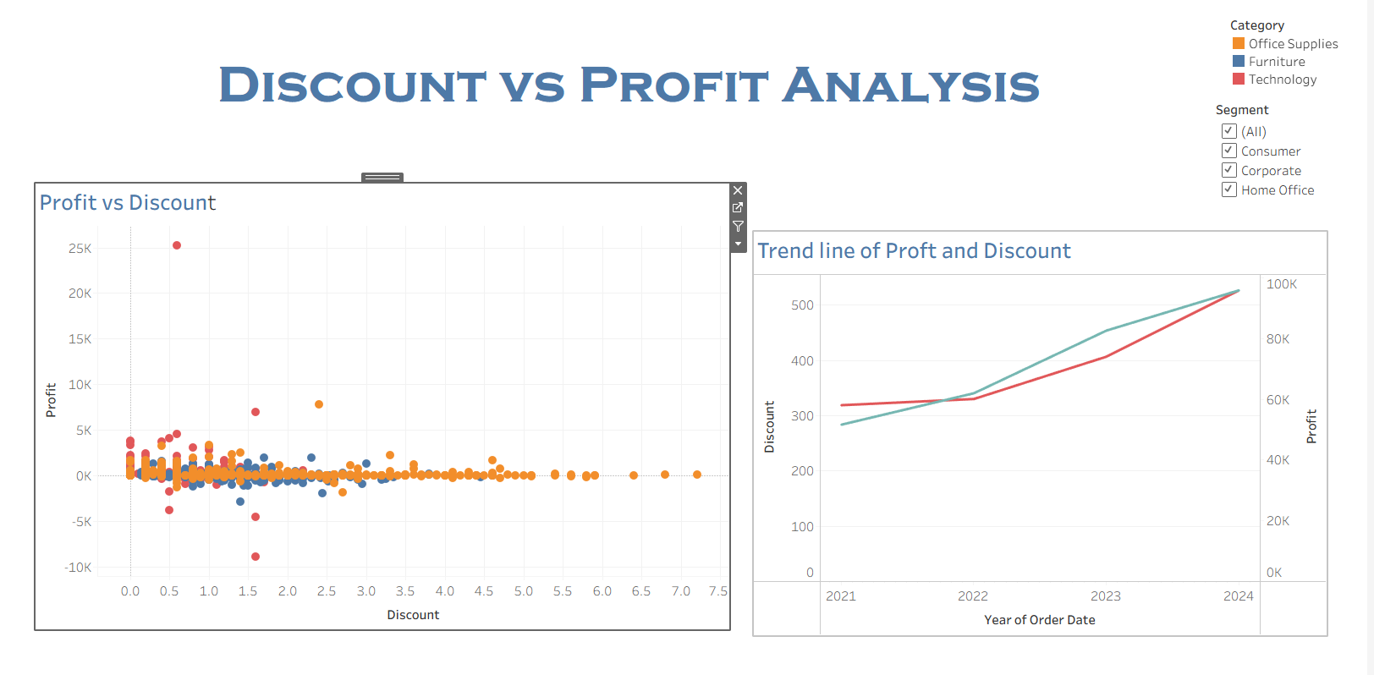
Discount and Profit dashboard

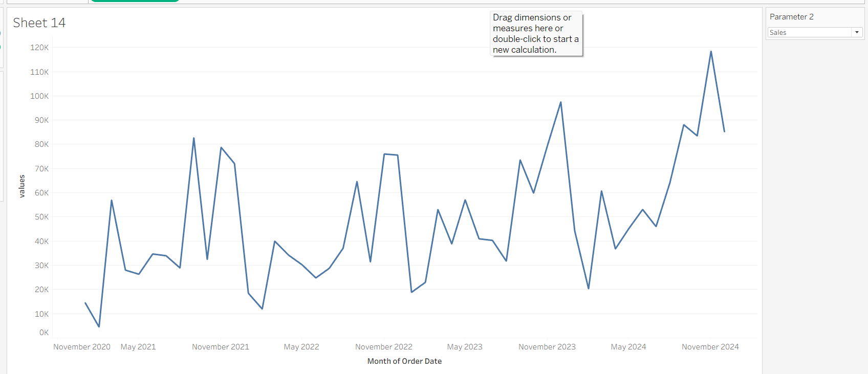
Parameter Control Chart

Result:
- Top Products: Technology and Office Supplies products—especially Phones, Chairs, and Machines—are the best performers across most regions.
- Sales & Profit Trends: Sales and profit change monthly, with some months showing high growth and others showing lower performance, helping identify strong and weak periods.
- Category Contribution: Technology and Office Supplies contribute the highest share of total revenue, with sub-categories like Chairs, Phones, and Machines playing a major role.
- Customer & Region Focus: The dashboard identifies top customers and high-performing regions to target for marketing, while also highlighting weak regions that may need improvement

